**Synopsis**

**PROJECT TITLE:**

MASTER OF COMPUTER APPLICATIONS

**SUBMITTED BY:**

**RUPESH KUMAR**



**UNIVERSITY NAME:- UPTU**

**ROLL NUMBER:- 1415514912**

**COURSE:- MCA**

**SEMESTER:- VI**

**Institute Name:- ECIMT**

**Introduction:**

The Multi Banking System Interface is targeted to the future banking solution for the users who is having multiple bank accounts in multiple banks. This interface integrates all existing banks and provides business solutions for both retail and corporate.

This system acts as a standard interface between the clients and all the banks, By using this portal any client who maintain accounts in various banks can directly log on to Multi Banking System Interface and make any kind of transactions. In the backend, system will take care of the entire obligation required in order to carry on transaction smoothly.

**EXISTING SYSTEM & DISADVANTAGES**

Currently we are having lot of banks in the market and any person can do transactions of any individual bank either manually or in online. But no one can do all banks transactions in a single portal or in single bank. This is the main disadvantage in existing system to avoid this problem we are introducing “multi banking system”.

**PROPOSED SYSTEM & ITS ADVANTAGES**

The Multi Banking System Interface is targeted to the future banking solution for the users who is having multiple bank accounts in multiple banks. This interface integrates all existing banks and provides business solutions for both retail and corporate.

This system acts as a standard interface between the clients and all the banks, By using this portal any client who maintain accounts in various banks can directly log on to Multi Banking System Interface and make any kind of transactions. In the backend, system will take care of the entire obligation required in order to carry on transaction smoothly.

**SYSTEM REQUIREMENT SPECIFICATIONS**

**Existing System:**

Currently we are having lot of banks in the market and any person can do transactions of any individual bank either manually or in online. But no one can do all banks transactions in a single portal or in single bank. This is the main disadvantage in existing system to avoid this problem we are introducing “multi banking system”.

**Proposed System:**

The Multi Banking System Interface is targeted to the future banking solution for the users who is having multiple bank accounts in multiple banks. This interface integrates all existing banks and provides business solutions for both retail and corporate.

This system acts as a standard interface between the clients and all the banks, By using this portal any client who maintain accounts in various banks can directly log on to Multi Banking System Interface and make any kind of transactions. In the backend, system will take care of the entire obligation required in order to carry on transaction smoothly.

### Need for Computerization

Computerization is absolutely necessary to facilitate or automate various procedures and several transactions. Some salient features of computerization are:

* reduction in processing time
* data security
* reduced redundancy & inconsistency

# **STUDY OF THE SYSTEM:**

To provide flexibility to the users, the interfaces have been developed that are accessible through a browser. The GUI’S at the top level have been categorized as

1. Administrative user interface
2. The operational or generic user interface

The ‘administrative user interface’ concentrates on the consistent information that is practically, part of the organizational activities and which needs proper authentication for the data collection. These interfaces help the administrators with all the transactional states like Data insertion, Data deletion and Date updation along with the extensive data search capabilities.

The ‘operational or generic user interface’ helps the end users of the system in transactions through the existing data and required services. The operational user interface also helps the ordinary users in managing their own information in a customized manner as per the included flexibilities.

# **Number of Modules**

After careful analysis the system has been identified to have the following modules:

1. **Admin Module**
2. **Customer Module**
3. **Bank Admin Module**
4. **Reports Module**

**1. Admin Module:**

The admin module will be used by the administrator of this portal, admin can accept or reject the requests from the bankers, and also admin can accept or reject the requests from the users. The requests are in the form of bank registration, customer registration. This module is having following functionalities.

* **Pending Bankers Requests:** By using this functionality Administrator can give access permeations to all bankers who are registered in this portal.
* **Pending User Requests:** By using this functionality Administrator can give access permeations to all users who are registered in this portal.

**2. Customer Module:**

This module describes all about customers, by using this module any customer can do some operations like create a new account, view the account information, Transfer amount from one account to other account and customer can also see the Transaction Reports. This module consists following functionalities.

* **Create New Account:** By using this functionality user can create a new account in any bank by selecting bank name option.
* **View Account Information:** By using this functionality user view all his account details, this can be viewed by users who are having account in any bank.
* **Transfer Amount:** By using this functionality user can transfer money from his account to other accounts of same bank or other banks.
* **Transaction Reports:** By using this functionality user can get all his transaction reports like accepted transactions, rejected transactions and pending transactions.

**3. Bank Admin Module:**

This module deals with all transactions of bank management. By using this module bank staff can view all details of customers, they can go for any transactions of their customers and also they can give access permeations to all customers of that bank. This module consists following functionalities.

* **List of Customers:** By using this functionality Bank admin can get their entire customers list and their details.
* **List of Accounts:** By using this functionality Bank admin can get their entire customers list based on selected account type like saving account, current account etc.
* **Transfer Pending:** By using this functionality Bank admin can maintain money transfer details of customers.
* **Transfer Declines:** By using this functionality Bank admin can maintain money transfer rejected customer details.
* **New Accounts Pending:** By using this functionality Bank admin can maintain entire user details who are requesting for new account in that bank.

**4. Reports Module:**

In this module administrator will get different types of reports regarding customers like Number of customers of this portal and no. of banks registered in this portal. This module is controlled by administrator only.

**Software Engineering Methodology:**

Object Oriented Analysis and Design (OOAD Standards)

**Non-Functional Requirements:**

**Software requirements**:

Operating System : Windows

Technology : Java/j2ee (JDBC, Servlets, JSP)

Web Technologies : Html, JavaScript, CSS

Web Server : Tomcat

Database : Oracle

Software’s : J2SDK1.5, Tomcat 5.5, Oracle 9i

**Hardware requirements**:

Hardware : Pentium based systems with a minimum of p4

RAM : 256MB (minimum)

**Additional Tools:**

HTML Designing : Dream weaver Tool

Development Tool kit : My Eclipse

**Project Approach:**

This Document plays a vital role in the development life cycle (SDLC) as it describes the complete requirements of the system. It is meant for use by the developers and will be the basic during testing phase. Any changes made to the requirements in the future will have to go through formal change approval process.

OOAD MODEL was being chosen because all requirements were known beforehand and the objective of our software development is the computerization/automation of an already existing manual working system.

**Umbrella Activity**

**Umbrella Activity**

**Umbrella Activity**

* TEAM FORMATION
* PP PREPARATION
* QP PREPARATION
* CMP PREPARATION
* FAMILIARIZATION
* START AUDIT / REVIEWS
* EFFORT CAPTURE
* STATUS REPORTS
* QD CONSOLIDATION
* STATUS REVIEW
* CHANGE REQUEST HANDLING

DESIGN & ANALYSIS

CODE

UNIT TEST

DOCUMENT CONTROL

* ASSESSMENT
* END AUDIT

TRAINING

INTEGRATION & SYSTEM TEST

DELIVERY/ INSTALLATION

ACCEPTANCE

REQUIREMENTS STUDY

**Fig: SDLC Model**

The developer is responsible for:

* Developing the system, which meets the SRS and solving all the requirements of the system?
* Demonstrating the system and installing the system at client's location after the acceptance testing is successful.
* Submitting the required user manual describing the system interfaces to work on it and also the documents of the system.
* Conducting any user training that might be needed for using the system.
* Maintaining the system for a period of one year after installation.

**INPUT DESIGN:**

Input design is a part of overall system design. The main objective during the input design is as given below:

* To produce a cost-effective method of input.
* To achieve the highest possible level of accuracy.
* To ensure that the input is acceptable and understood by the user.

**INPUT STAGES:**

The main input stages can be listed as below:

* Data recording
* Data transcription
* Data conversion
* Data verification
* Data control
* Data transmission
* Data validation
* Data correction

**INPUT TYPES:**

It is necessary to determine the various types of inputs. Inputs can be categorized as follows:

* External inputs, which are prime inputs for the system.
* Internal inputs, which are user communications with the system.
* Operational, which are computer department’s communications to the system?
* Interactive, which are inputs entered during a dialogue.

**INPUT MEDIA:**

At this stage choice has to be made about the input media. To conclude about the input media consideration has to be given to;

* Type of input
* Flexibility of format
* Speed
* Accuracy
* Verification methods
* Rejection rates
* Ease of correction
* Storage and handling requirements
* Security
* Easy to use
* Portability

Keeping in view the above description of the input types and input media, it can be said that most of the inputs are of the form of internal and interactive. As

Input data is to be the directly keyed in by the user, the keyboard can be considered to be the most suitable input device.

**OUTPUT DESIGN:**

Outputs from computer systems are required primarily to communicate the results of processing to users. They are also used to provide a permanent copy of the results for later consultation. The various types of outputs in general are:

* External Outputs whose destination is outside the organization.
* Internal Outputs whose destination is with in organization and they are the User’s main interface with the computer.
* Operational outputs whose use is purely with in the computer department.
* Interface outputs, which involve the user in communicating directly with the system.

**OUTPUT DEFINITION**

# The outputs should be defined in terms of the following points:

* + - Type of the output
    - Content of the output
    - Format of the output
    - Location of the output
    - Frequency of the output
    - Volume of the output
    - Sequence of the output

It is not always desirable to print or display data as it is held on a computer. It should be decided as which form of the output is the most suitable.

For Example

* Will decimal points need to be inserted
* Should leading zeros be suppressed.

**OUTPUT MEDIA:**

In the next stage it is to be decided that which medium is the most appropriate for the output. The main considerations when deciding about the output media are:

* The suitability for the device to the particular application.
* The need for a hard copy.
* The response time required.
* The location of the users
* The software and hardware available.

Keeping in view the above description the project is to have outputs mainly coming under the category of internal outputs. The main outputs desired according to the requirement specification are:

The outputs were needed to be generated as a hard copy and as well as queries to be viewed on the screen. Keeping in view these outputs, the format for the output is taken from the outputs, which are currently being obtained after manual processing. The standard printer is to be used as output media for hard copies.

**Context Diagram:**

Admin

Controlling both banks & customers

Register

Register

0

**Multi Banking**

**System**

Customers

Banks

Customer interaction

Bank transactions



Stores data

**Architecture flow:**

**SERVER**

**User**

**Data Base**

**Request**

**Response**

**URL Pattern:**

**Presentation Layer**

**SERVLETS AT THE SERVER SIDE**

**URL Request sent through the browser**

**Response sent from the servlet**

**DATABASE**

**Verifying or updating the database** **through a statement**

**Reply from the database according to the statement**

**Performance Requirements:**

Performance is measured in terms of the output provided by the application. Requirement specification plays an important part in the analysis of a system. Only when the requirement specifications are properly given, it is possible to design a system, which will fit into required environment. It rests largely with the users of the existing system to give the requirement specifications because they are the people who finally use the system. This is because the requirements have to be known during the initial stages so that the system can be designed according to those requirements. It is very difficult to change the system once it has been designed and on the other hand designing a system, which does not cater to the requirements of the user, is of no use.

The requirement specification for any system can be broadly stated as given below:

* The system should be able to interface with the existing system
* The system should be accurate
* The system should be better than the existing system

The existing system is completely dependent on the user to perform all the duties.

**Feasibility Report:**

Preliminary investigation examines project feasibility, the likelihood the system will be useful to the organization. The main objective of the feasibility study is to test the Technical, Operational and Economical feasibility for adding new modules and debugging old running system. All systems are feasible if they are given unlimited resources and infinite time. There are aspects in the feasibility study portion of the preliminary investigation:

* Technical Feasibility
* Operation Feasibility
* Economical Feasibility

**Technical Feasibility:**

The technical issue usually raised during the feasibility stage of the investigation includes the following:

* Does the necessary technology exist to do what is suggested?
* Do the proposed equipments have the technical capacity to hold the data required to use the new system?
* Will the proposed system provide adequate response to inquiries, regardless of the number or location of users?
* Can the system be upgraded if developed?
* Are there technical guarantees of accuracy, reliability, ease of access and data security?

**Operational Feasibility:**

Proposed projects are beneficial only if they can be turned out into information systems, that will meet the organization’s operating requirements. Operational feasibility aspects of the project are to be taken as an important part of the project implementation. Some of the important issues raised are to test the operational feasibility of a project includes the following: -

* Is there sufficient support for the management from the users?
* Will the system be used and work properly if it is being developed and implemented?
* Will there be any resistance from the user that will undermine the possible application benefits?

This system is targeted to be in accordance with the above-mentioned issues. Beforehand, the management issues and user requirements have been taken into consideration. So there is no question of resistance from the users that can undermine the possible application benefits.

The well-planned design would ensure the optimal utilization of the computer resources and would help in the improvement of performance status.

**Economic Feasibility:**

A system can be developed technically and that will be used if installed must still be a good investment for the organization. In the economical feasibility, the development cost in creating the system is evaluated against the ultimate benefit derived from the new systems. Financial benefits must equal or exceed the costs. The system is economically feasible. It does not require any additional hardware or software.

**DFD DIAGRAMS:**

**Context Level Dfd**

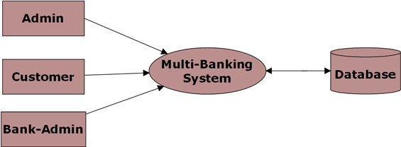

**Level 0 DFD for Admin:**

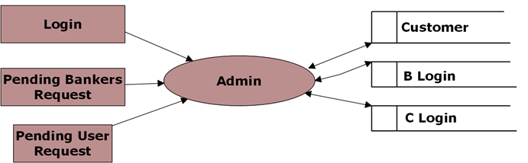

**Level 0 DFD for Customer:**

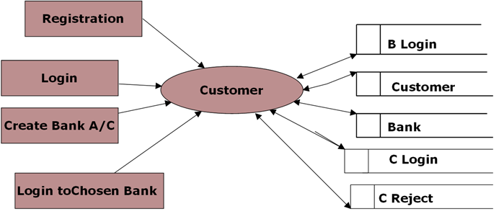

**Level 0 DFD for Bank Admin:**

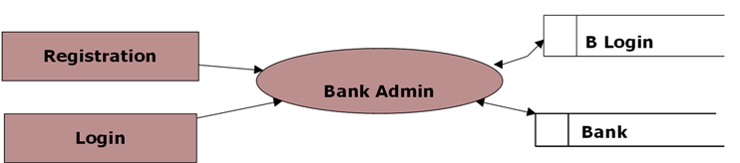

**Level 1 DFD for Chosen Bank:**

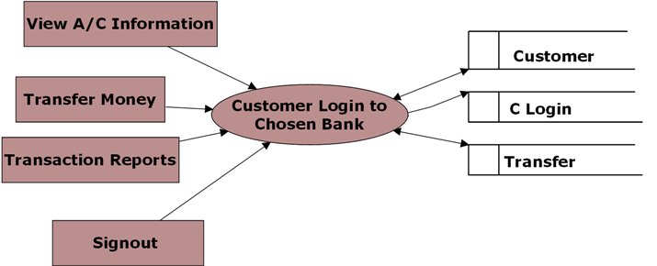

**Level 1 DFD for Banker Login:**

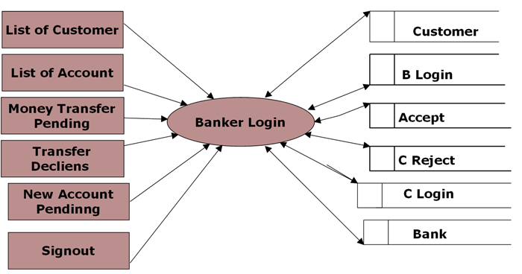

**Level 2 for Money Transfer:**

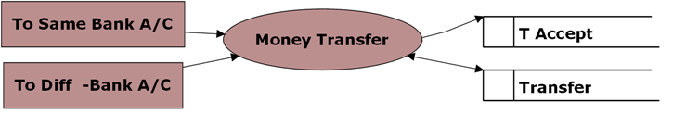

**Level 2 DFD for Transaction Reports:**

